Deliverables

Automatically build a scenario
For the work outlined above, a basic version of an Ecospace scenario generation wizard was developed that enabled to:
- Support users in the task of creating a new Ecospace scenario with a defined name, spatial extent and cell size;
- Support users in the task to identify external spatial data (e.g., EMIS) for the content of Ecospace layers Depth, Relative Primary Productivity, Temperature and Salinity;
- Automatically populate the content of these Ecospace layers from external GIS data via Geographic Information System (GIS) capabilities;
- Provide a simple and efficient user interface that supports the tasks outlined here;
- Remember the scenario generation parameters last used by a user, which can be recalled when restarting the scenario wizard. This greatly facilitates the process of generating similar scenarios with slightly different parameters, which can be useful to explore the dynamics in Ecospace scenarios with different map scales.
Implementation
Therefore, the following developments were done:
- Design and implement the scenario generation wizard core logic. The wizard will generate a full Ecospace scenario, including all map layers that a basic Ecospace needs. Additionally, the wizard will generate two extra environmental data layers: Salinity and Temperature;
- Implement a data exchange interaction between the spatial-temporal framework and the Ecospace depth layer. Data exchange interactions to the other three layers have already been implemented;
- Use abilities of the spatial-temporal data framework to populate the indicated layers Depth, Primary Production, Salinity and Temperature. The wizard will receive structural flexibility to be extended with other spatial layers at a future project;
- Implement a user interface. The user interface will also receive structural flexibility to be extended in a future project;
- Implement a system that preserves the scenario generation settings. These settings will be stored with the EwE model, and can be reloaded into the scenario generation wizard user interface.
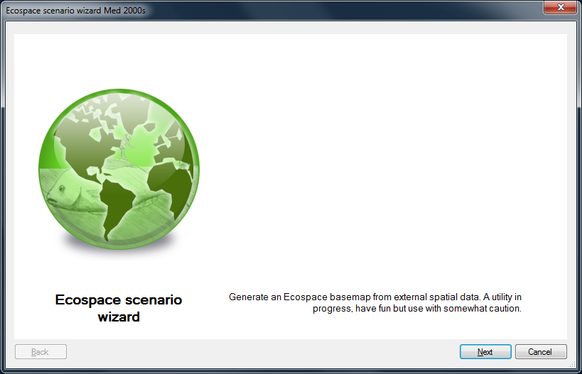

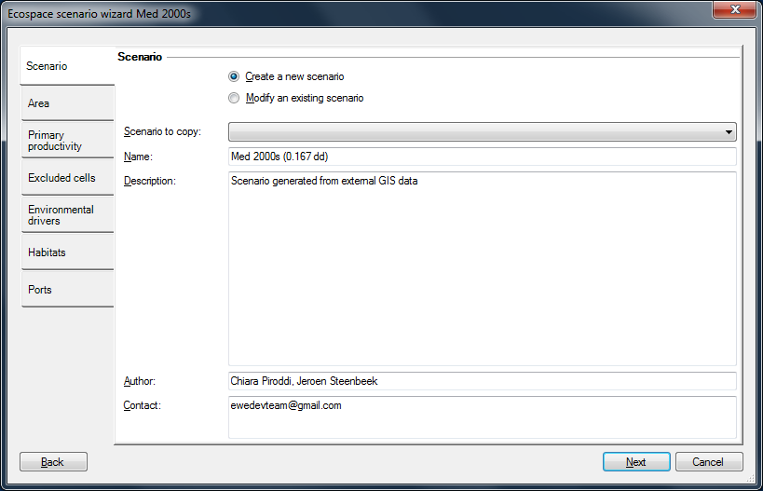
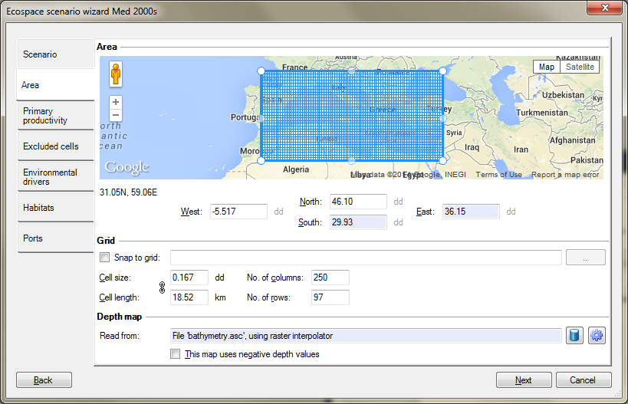
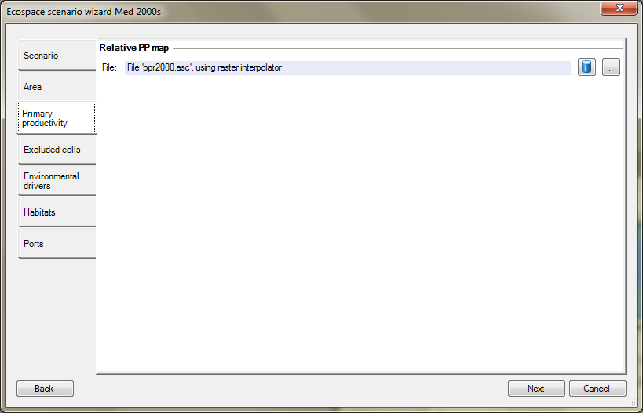

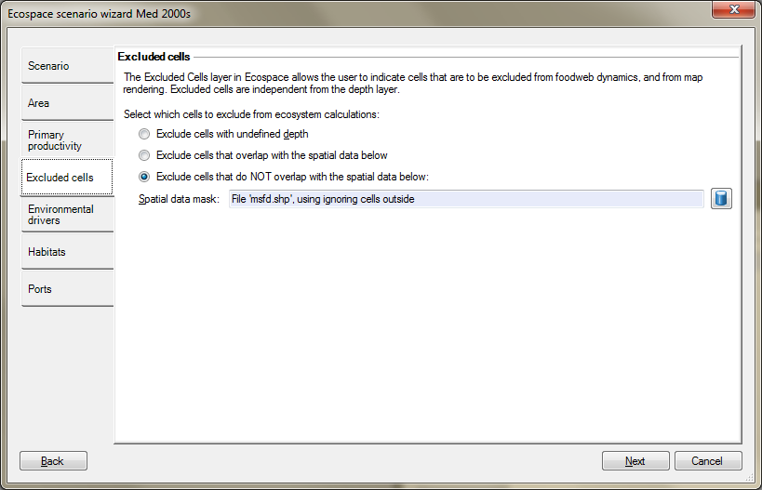

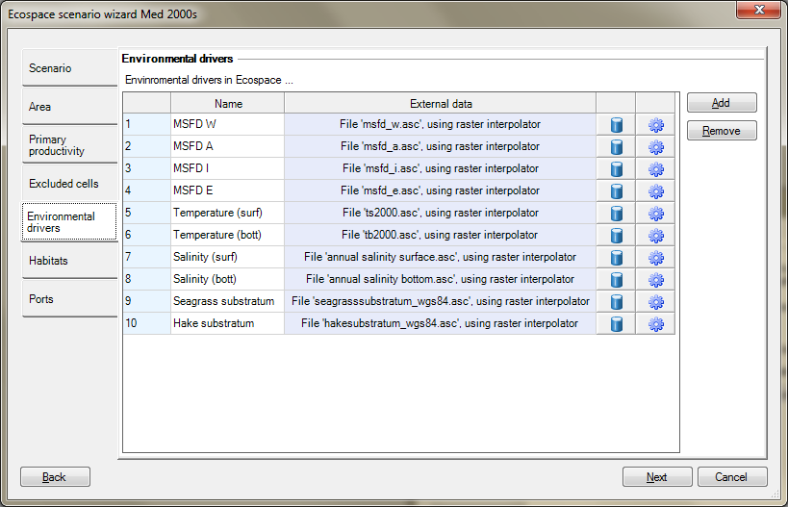

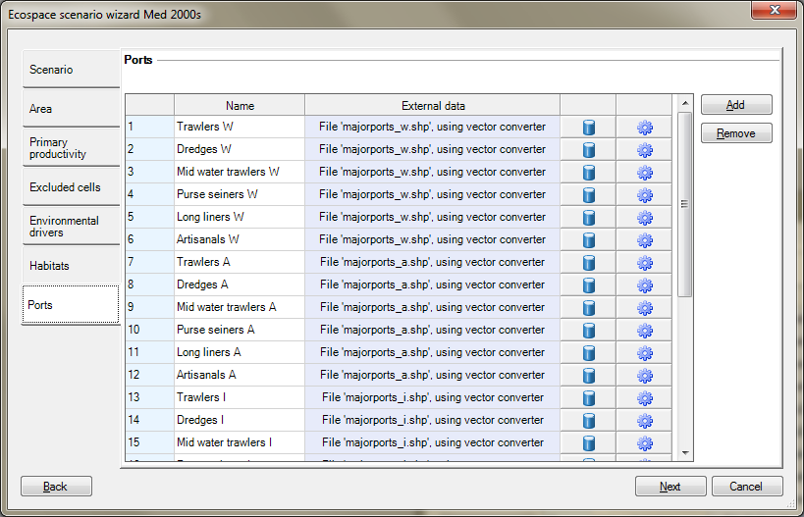

Populate the Ecospace layers with JRC data

JRC data were downloaded and manipulated to be fit for automatic processing by Ecospace (examples of temperature, depth and primary production displayed in figures below)

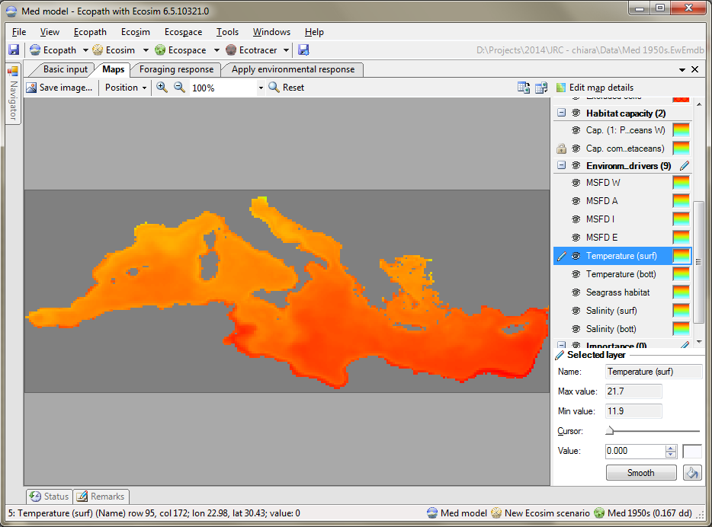

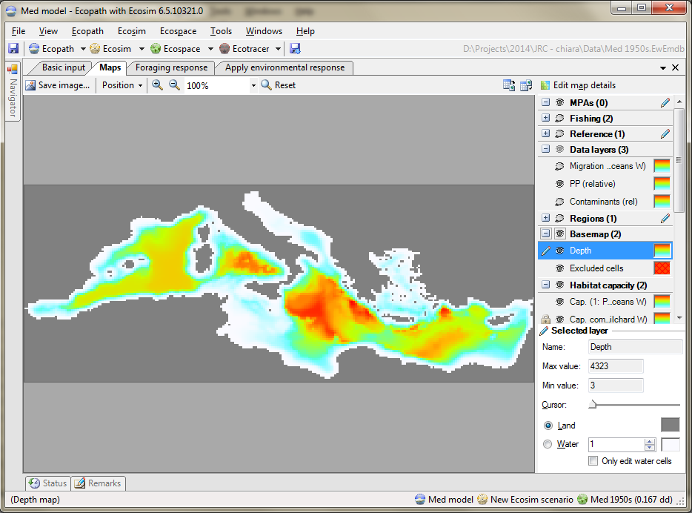

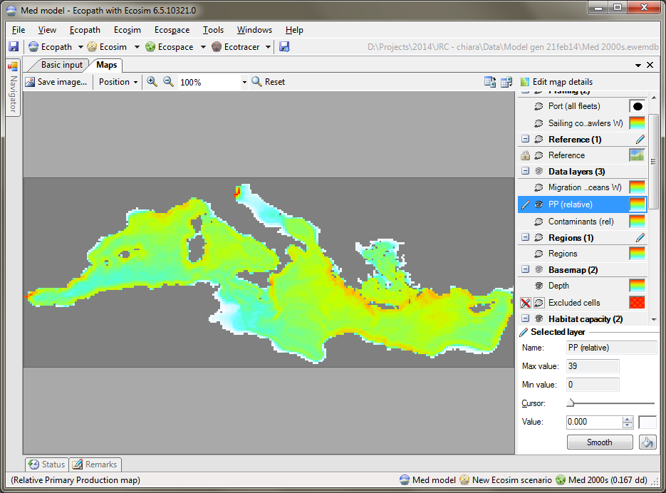

Define species distributions
Species distributions were driven by the content of the scenario layers Depth, Salinity and Temperature. The Primary Production layer was used to add effect through the regular food web dynamics. No software development was needed to implement these requested dynamics; the habitat capacity model is fully developed to accommodate this project. However, parameterizing the capacity model with functional responses to environmental drivers of target functional groups was subject of the on-site sessions at JRC (examples of environmental drivers, their application to JRC models and sardines and whales distributions in figures below).
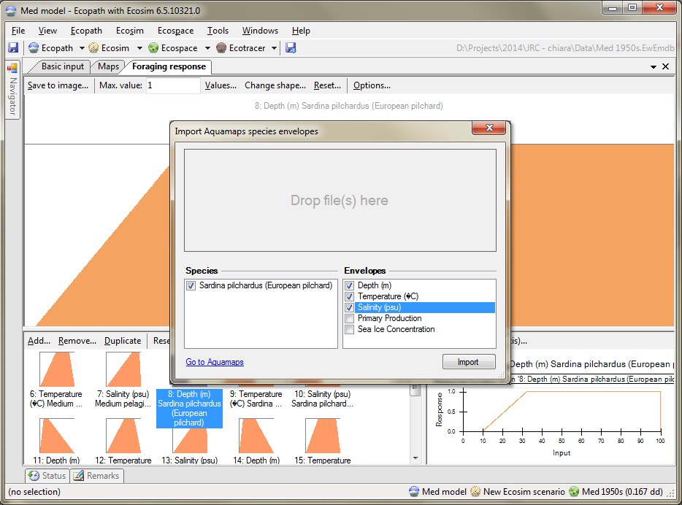

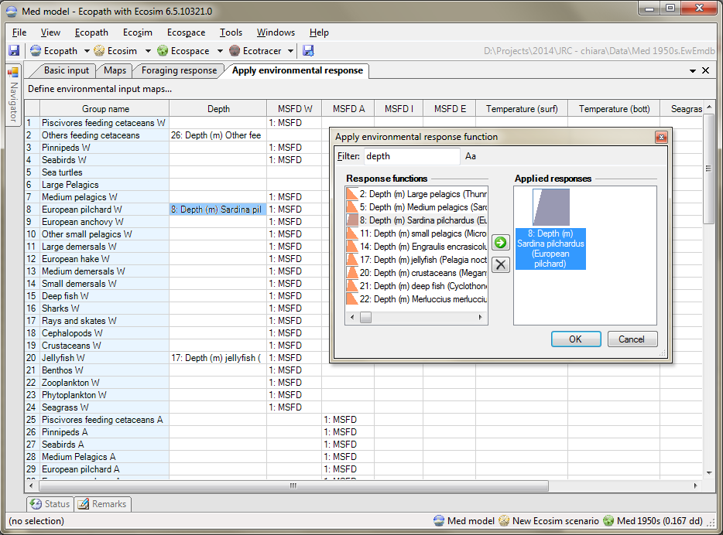

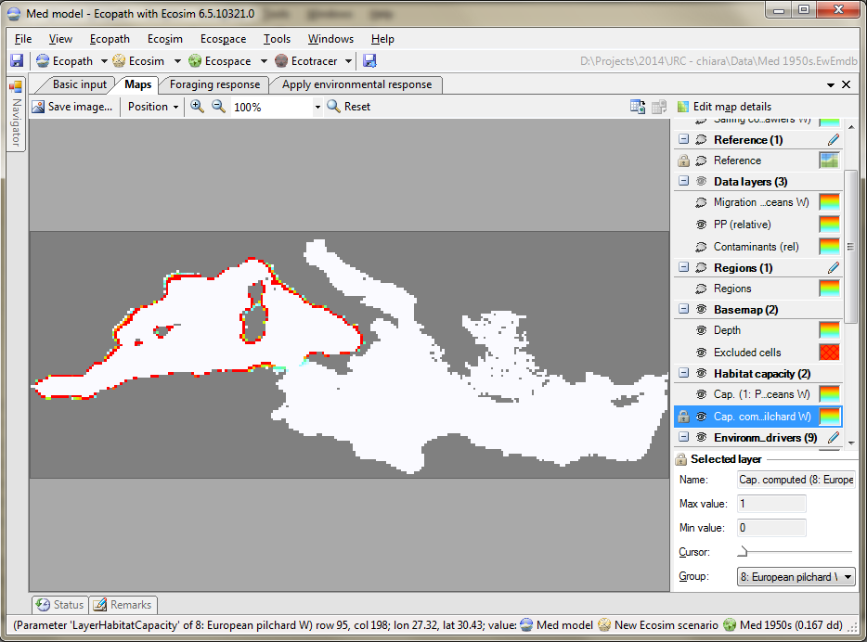

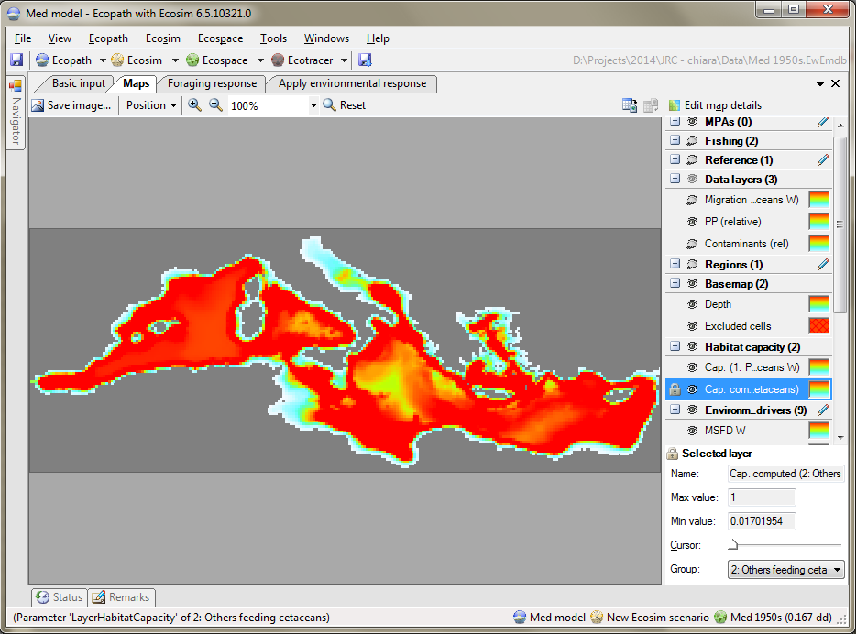

Extracting maps
Extraction of biomass, catch and biodiversity indicators maps was implemented in the software.

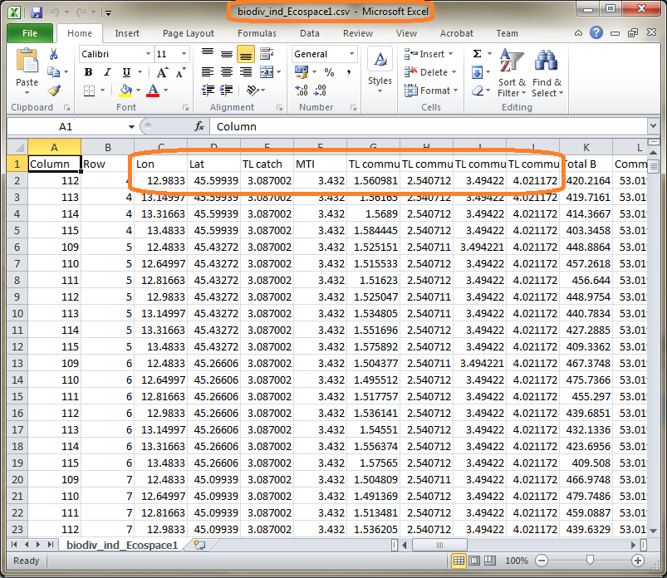

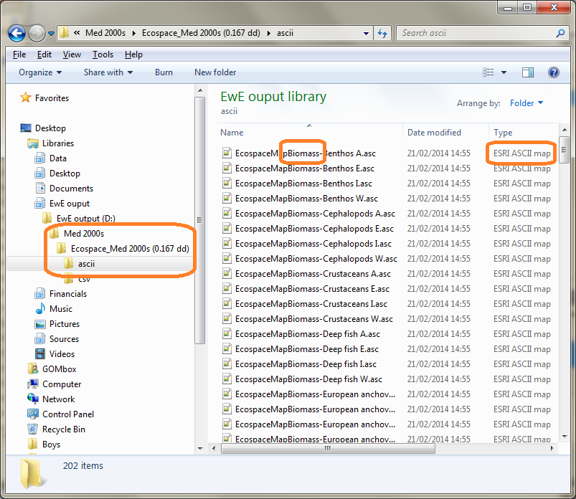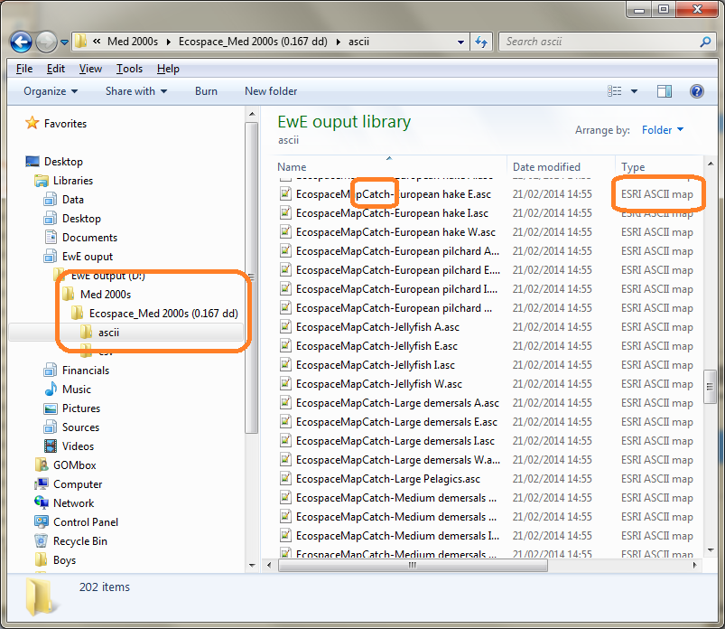

Drive a running model with distributions of fishing effort and primary production
Currently, the Ecospace model drives the distribution of fishing effort via three factors:
- The distributions of functional groups targeted by fishing fleets (see figure above of sardines)
- Fishing cost (such as can be derived from distance to ports) (ports displayed as red dots and fishing cost in figure below)

